Chinook Music Store Project
OBJECTIVE QUESTION
Q1. Does any table have missing values or duplicates? If yes how would you handle it ?
Code:
Part A — Check for missing values (NULL)
- I checked the important columns in the tables to identify whether any values were missing (NULL).
- For example, company in the customer table, reports_to in the employee table, and composer in the track table were checked.
- I did not remove the records just because they contained NULL values, because a missing value can be valid for example, an employee at the top level may not have a manager.
- For reporting purposes, COALESCE() can be used to display a suitable value such as “Not Provided” instead of NULL.

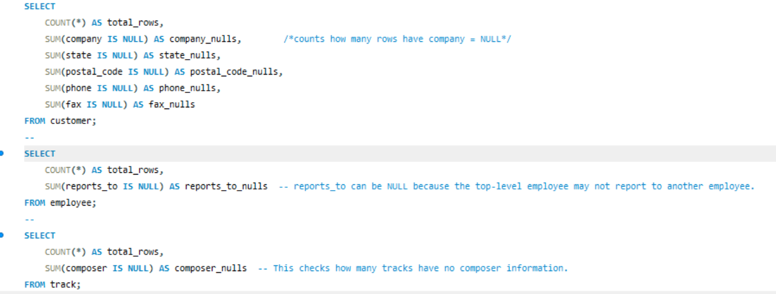

Output
/*counts how many rows have company = NULL*/
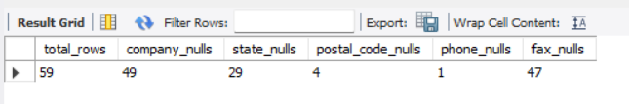

/*reports_to can be NULL because the top-level employee may not report to another employee.*/
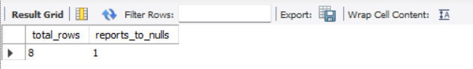

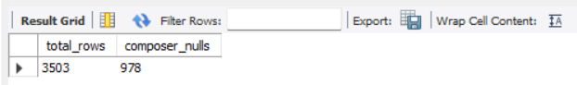
This is of Track_Table

Part B — Check for duplicates
- The best first check is to look for duplicate primary-key values.
1. customer
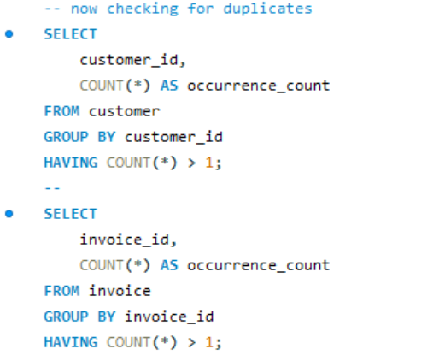
/*This returns no rows, there are no duplicate customer_id values.*/
/*Likewise executed for all other tables(artist , album , employee , genre , invoice , invoice_line , media_type , playlist , track) , all will return no rows, there are no duplicate primary key values */
2. playlist_track (This one is different because it has a composite primary key)
PRIMARY KEY (playlist_id, track_id)
So we have to check the combination:
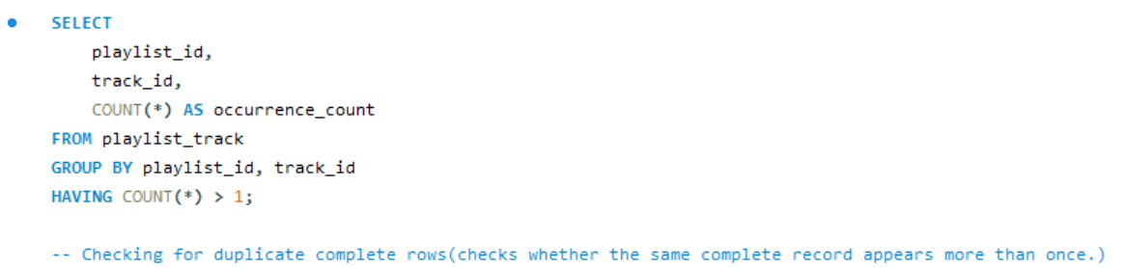
/* No duplicates found*/

- checked all customer details and grouped the records based on all customer columns.
- COUNT(*) was used to identify if the exact same customer record appeared more than once. HAVING COUNT(*) > 1 filters only records that occur multiple times.
- No duplicate records were found in the customer table.
/* no duplicates found*/
Part D — Check the 'None' problem
- SQL data contains literal text values such as: ‘NONE’ in invoice location fields. These are not SQL NULLs.
- NONE is a valid input. Therefore cant not be treated as NULL.

Handling missing values ?
- Some columns contain NULL values, such as company, state, postal_code, phone, and fax in the customer table, and composer in the track table.
- I would not automatically delete rows containing NULL values, because a missing value does not necessarily mean that the record is invalid. For example, a customer may not have a company or fax number.
For analysis or reporting, I can handle missing values using COALESCE():
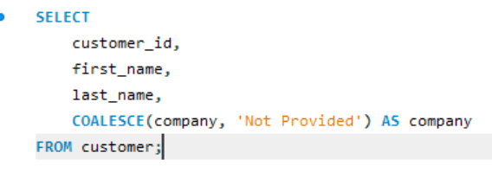
This replaces NULL only in the query result; it does not modify the original database.
For numerical columns, if a missing value genuinely needs to be filled, an appropriate method such as the median, average, or a business-defined value could be used, only if it doesn’t change the meaning of the data

Q2. Find the top-selling tracks and top artist in the USA and identify their most famous genres.
Using quantity sold (SUM(invoice_line.quantity)) rather than simply counting rows, because quantity represents how many units of a track were purchased. The sales path in Chinook is invoice → invoice_line → track → album → artist, while genre is connected through track.
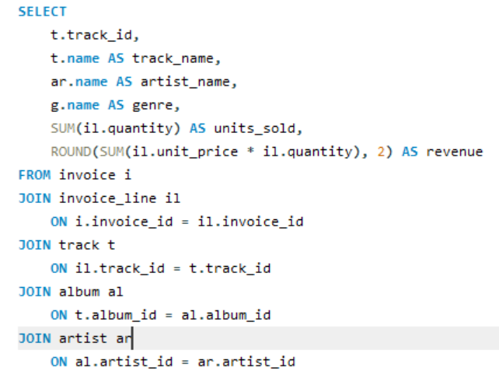
Code: Top-selling tracks in the USA
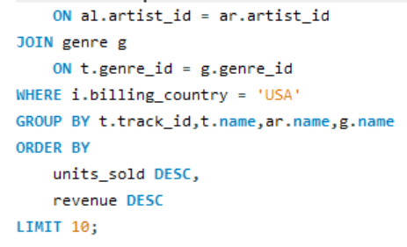

- I identified the top-selling tracks by calculating the total quantity sold using SUM(invoice_line.quantity).
- I used quantity instead of simply counting invoice rows because the quantity tells us how many units of a track were actually purchased.
- The analysis was restricted to USA purchases using billing_country = 'USA', and the results were sorted from highest to lowest sales.

Output
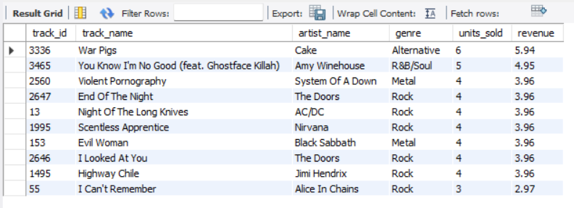

/*So, War Pigs is the top-selling track in the USA with 6 units sold. */
2. Find the top-selling artist in the USA
For the artist, we need to aggregate all tracks belonging to that artist.
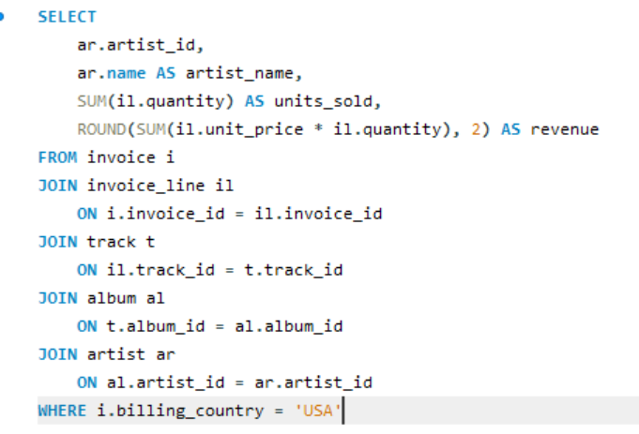
Output
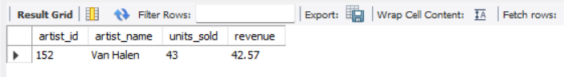

/*So, according to the supplied dataset, Van Halen is the top-selling artist in the USA, with 43 units sold.*/
3. Identifying the most famous genre of the top artist
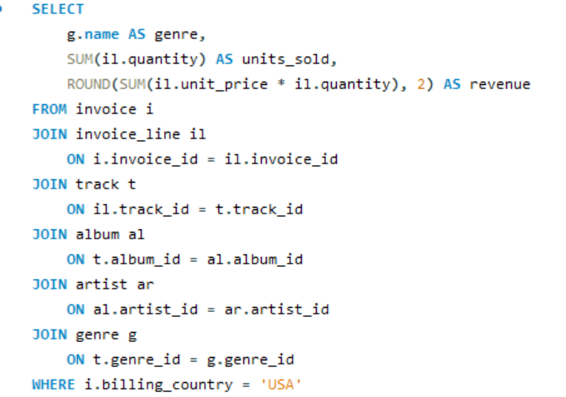
Here, "most famous" should be interpreted as the genre with the highest number of USA sales for that artist.

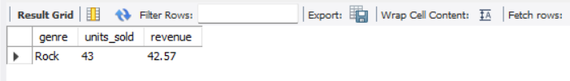
Output

/* Van Halen is the top-selling artist in the USA, with 43 units sold, and Rock is the artist's most popular genre in terms of USA sales. The top-selling individual track is "War Pigs" by Cake, classified as Alternative, with 6 units sold. */
Brief Explaination:
Here "top-selling track" and "top-selling artist" are different
Track: SUM(quantity) for each individual track.
Artist: SUM(quantity) across all tracks/albums belonging to that artist.
Genre: SUM(quantity) for tracks belonging to that genre.
That distinction is important for your project because the artist is connected to sales indirectly:
Artist → Album → Track → Invoice_Line → Invoice → USA
while genre is:
Genre → Track → Invoice_Line → Invoice → USA.

Q3. What is the customer demographic breakdown (age, gender, location) of Chinook's customer base?
Code:
1. Age and gender breakdown
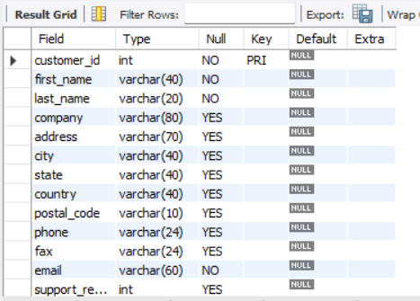
Describe customer;

Age-wise and gender-wise demographic analysis cannot be performed because the Chinook customer table does not contain age or date-of-birth or gender information.
2. Location breakdown
Location is available through: country, state, city and postal_code.
But i will use a single query for a clean result of overall location breakdown.
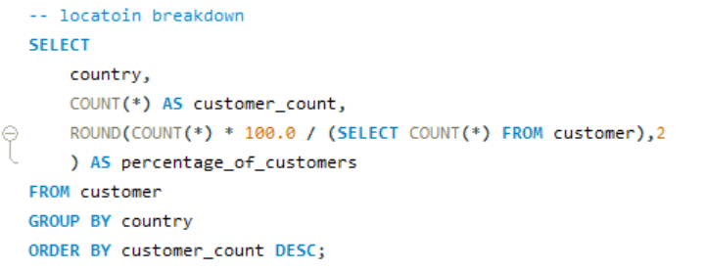
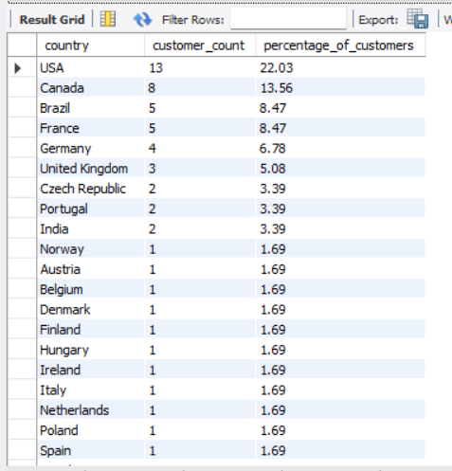
OUTPUT
t
The chart shows that the USA generates the highest revenue, followed by Canada and Brazil, while several countries contribute smaller amounts.

Q4. Calculate the total revenue and number of invoices for each country, state, and city.
Code:
- Revenue and invoices by Country
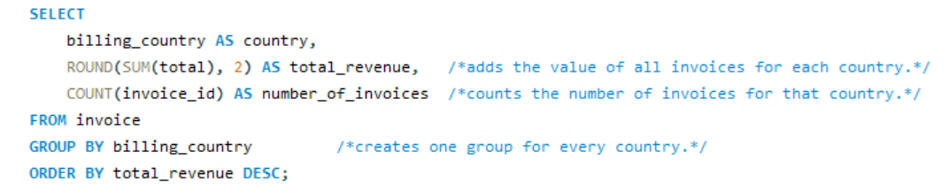
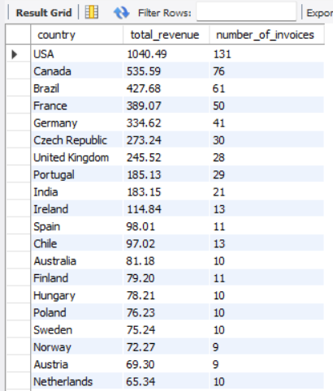
Output

2. Revenue and invoices by State
Because state is meaningful mainly within a country, I am including the country along with the state.
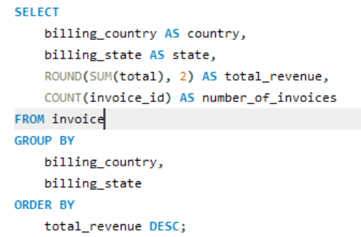

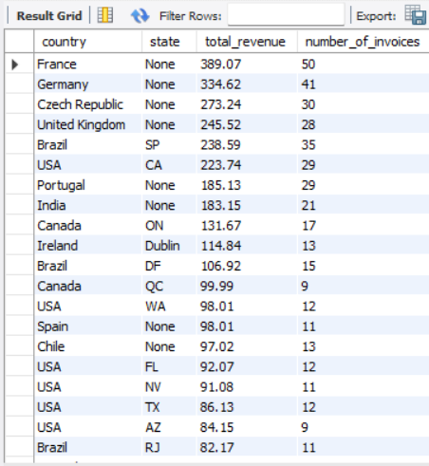
Output

/*I included country because:
Suppose two different countries have a state called: California
If we only do: GROUP BY billing_state both would be combined ,Using:
GROUP BY billing_country, billing_state , keeps them separate.*/
3. Revenue and invoices by City
Again, include the country and state so that the geographic hierarchy remains clear:
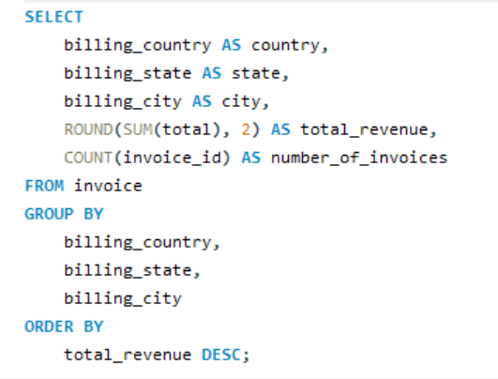
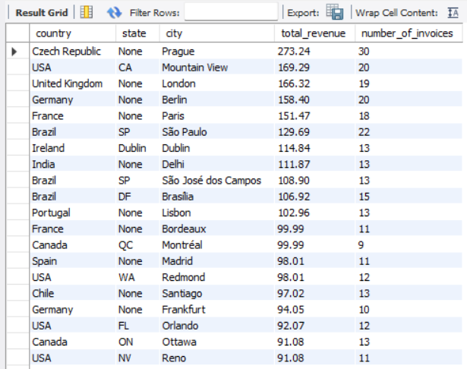
Output

Q5. Find the top 5 customers by total revenue in each country
- The total revenue of each customer was calculated by joining the customer and invoice tables using customer_id.
- A window function with PARTITION BY country was then used to rank customers based on their total revenue within each country.
- ROW_NUMBER() assigns a separate rank starting from 1 for every country.
- Finally, only customers with a rank from 1 to 5 were selected to identify the top five customers in each country.

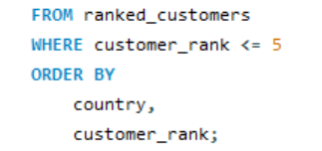
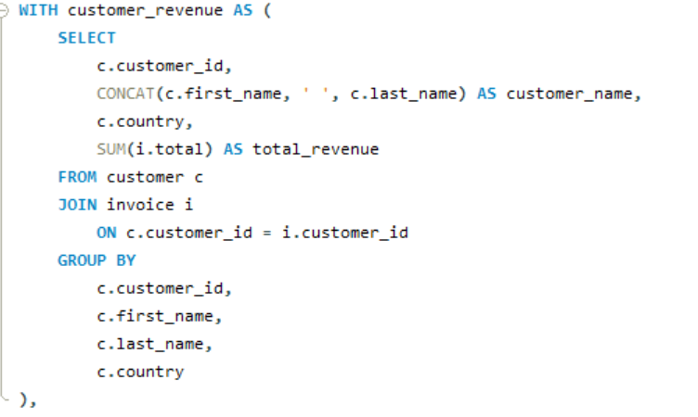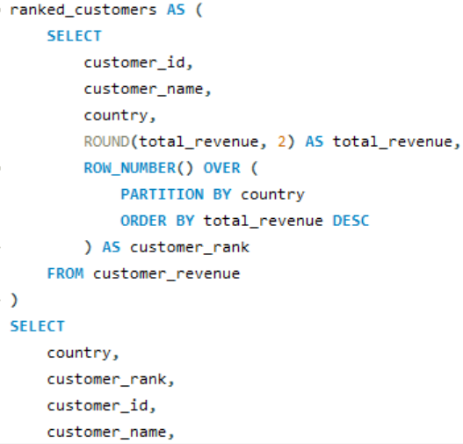

Output
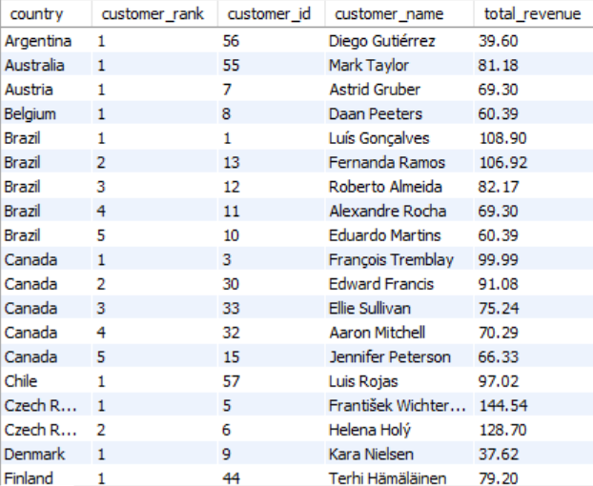
This chart perticularly Demonstrates USA: The chart shows that Jack Smith has the highest revenue, followed by Dan Miller, Heather Leacock, Kathy Chase, and Richard Cunningham.

6. Identify the top-selling track for each customer

- The total revenue of each customer was calculated by joining the customer and invoice tables using customer_id.
- A window function with PARTITION BY country was then used to rank customers based on their total revenue within each country
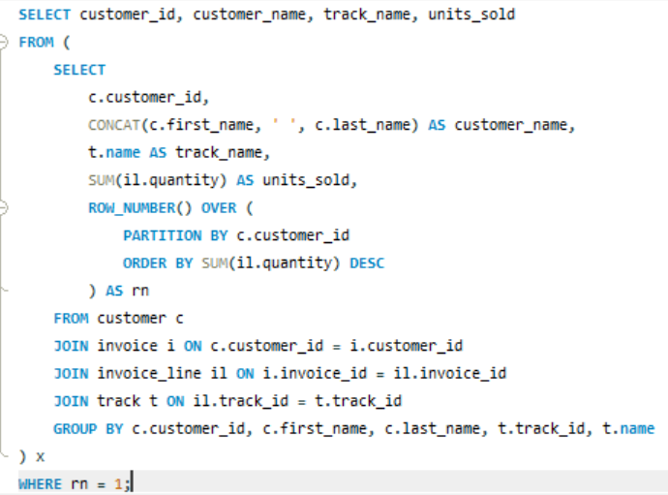

- ROW_NUMBER() assigns a separate rank starting from 1 for every country.
- Finally, only customers with a rank from 1 to 5 were selected to identify the top five customers in each country.
- Finally, WHERE rn = 1 returns only the top-selling track for each customer.
Output
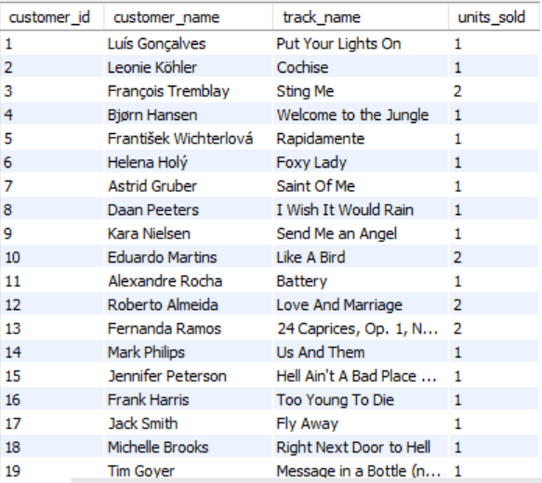
The units_sold value shows how many times the customer purchased their top-selling track.
This helps identify individual customer preferences and can be used for personalized music recommendations.

7. Are there any patterns or trends in customer purchasing behavior (e.g., frequency of purchases, preferred payment methods, average order value)?
- To analyse customer purchasing behaviour, I examined three key metrics: purchase frequency, average order value, and total spending.
- Purchase frequency shows how often each customer makes a purchase, while average order value shows the average amount spent per invoice.
- Total spending represents the overall amount spent by each customer.
- These metrics help identify frequent customers and high-value customers and provide insights into their purchasing patterns.
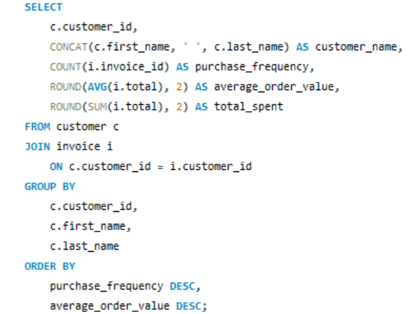
The database does not contain information about payment methods, so preferred payment methods could not be analysed
COUNT(i.invoice_id) → how many purchases/invoices each customer has made.
AVG(i.total) → the customer's average amount spent per order.
SUM(i.total) → the customer's total spending.
Customers are first ordered by purchase frequency, then by average order value.

Key Insight
The analysis helps identify customers who purchase frequently and customers who spend more per order. These customers can be considered for loyalty programs, personalised offers, and other customer-retention strategies.
Output
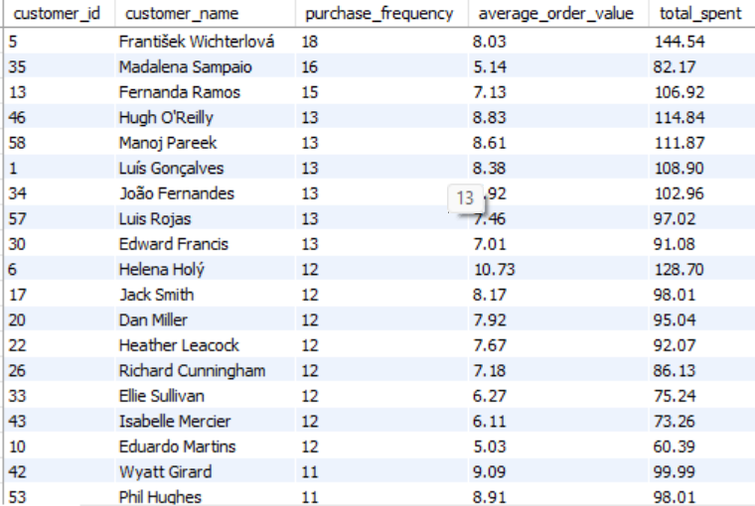
The results help identify customers who purchase frequently and customers who spend more per order.
Each dot represents a customer. It helps you see whether customers who make more purchases also tend to have a higher average order value.

8. What is the customer churn rate?
- Customer churn rate represents the percentage of customers who have stopped transacting or disengaged with the business during a specific period.
- Monitoring churn helps a business understand customer retention, loyalty, and potential customer loss
For this analysis, the Chinook database does not contain a direct churn_status or active/inactive column. Therefore, churn has to be defined based on customer purchase activity
In this analysis, a customer is considered churned if they have not made a purchase for more than 6 months from the latest available invoice date.
Query
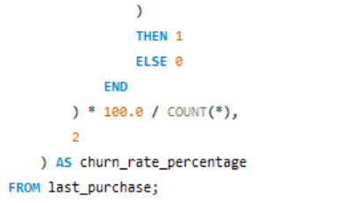
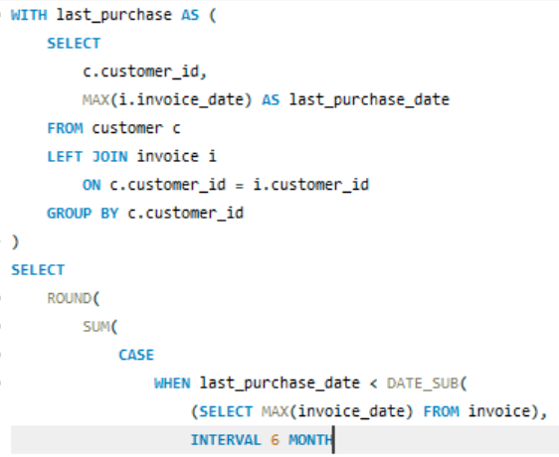

Customer churn rate is calculated by identifying customers whose last purchase was more than six months before the latest invoice date in the database.
The MAX(invoice_date) function determines each customer's most recent purchase. Customers inactive for more than six months are considered churned.
The churn rate is then calculated as the percentage of churned customers out of the total customer base.
Formula:
Churn Rate = (Number of Churned Customers / Total Customers) × 100
So the query is checking:
Is the customer's last purchase more than 6 months before the latest purchase date in the database?
If yes → customer is considered churned.
If no → customer is considered active.
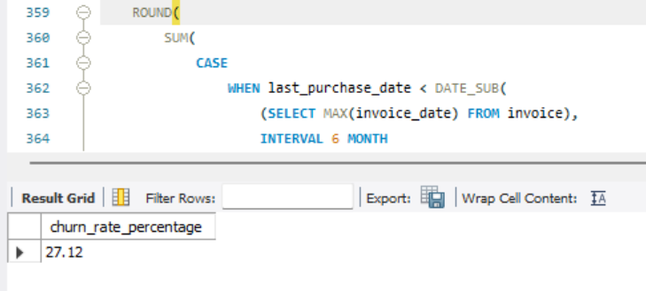
Output

9. Calculate the percentage of total sales contributed by each genre in the USA and identify the best-selling genres and artists.
I Took “sales” as revenue, calculated as UnitPrice × Quantity. This is more appropriate than simply counting tracks
This analysis determines each genre’s contribution to total music sales in the USA and identifies the top-selling artist within each genre. This helps recognize customer preferences and can support inventory and marketing decisions.
For this analysis, sales are calculated as UnitPrice × Quantity, which represents the actual revenue generated from each invoice line.
Percentage of total sales by genre in the USA
This query calculates the total sales generated by each genre in the USA and determines each genre's percentage contribution to overall USA sales.
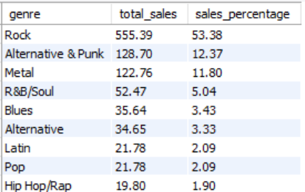
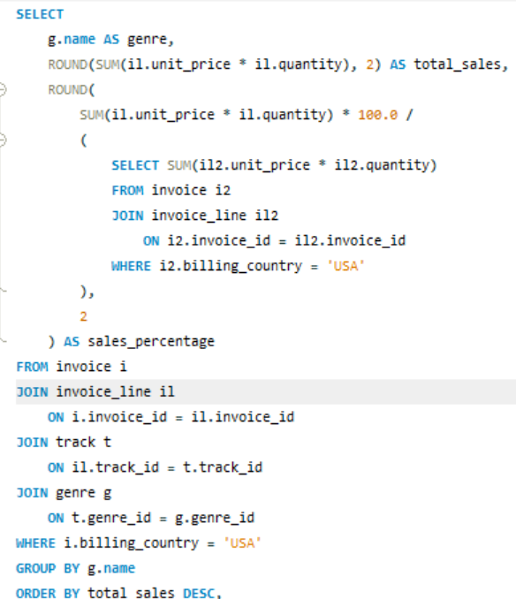
Revenue is calculated by multiplying the unit price by the quantity purchased.
The genres are then grouped and ordered from highest to lowest sales to identify the best-selling genres
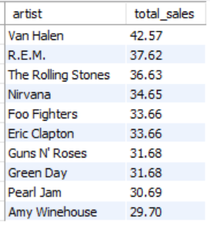
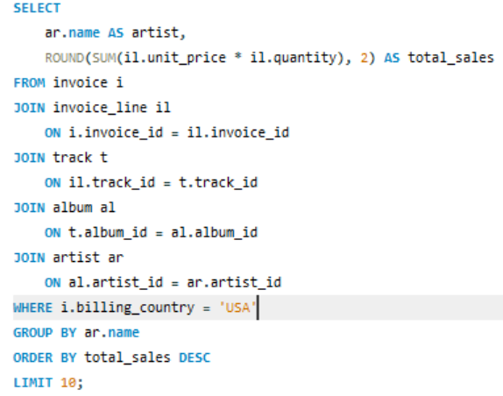
Best-selling artists in the USA

- This query identifies the top-selling artists in the USA by calculating the total revenue generated from their tracks.
- The tables are joined through Track, Album, and Artist to connect each sale with its artist.
- The artists are ranked by total sales, with the highest revenue-generating artists appearing first.
Q10. Find customers who have purchased tracks from at least 3 different+ genres
This analysis identifies customers whose purchases span at least three different music genres.
This helps identify customers with diverse music preferences and can be useful for understanding highly engaged customers
To answer this question, I have used the following MySQL syntax:
Query
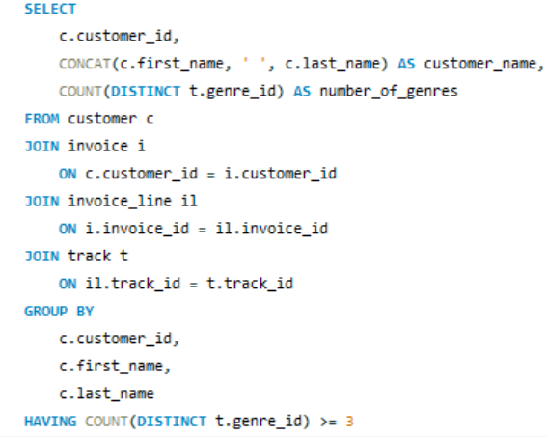
- This query identifies customers who have purchased tracks from at least three different genres.
- The customer, invoice, invoice line, and track tables are joined to connect customers with their purchases.
- COUNT(DISTINCT genre_id) is used to count the unique genres purchased by each customer, while the HAVING clause filters customers who have purchased tracks from three or more genres.
- The results are ordered by the number of genres purchased in descending order.
multiple customers have purchased tracks across a wide range of genres, with some customers purchasing from 12–14 different genres. These customers demonstrate particularly diverse music preferences. The provided material also describes such multi-genre customers as highly engaged users.
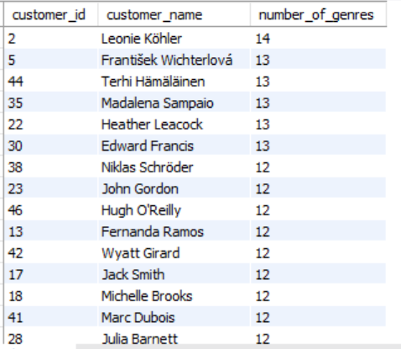
Output

11. Rank genres based on their sales performance in the USA
For this question, I ranked genres based on total sales revenue in the USA. This gives a clear ranking of which genres generate the most revenue.
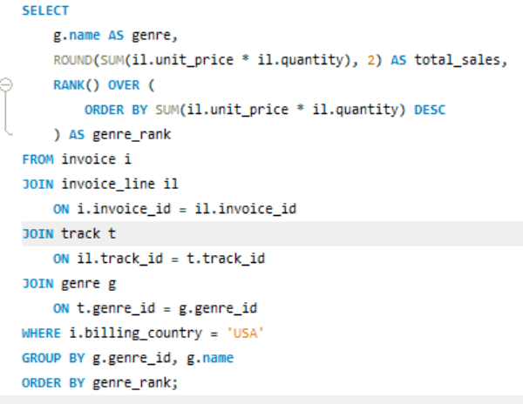
I have ranked the genres based on their total sales revenue in the USA. Revenue is calculated using UnitPrice × Quantity.

This query ranks all genres based on their total sales revenue in the USA.
The Invoice, InvoiceLine, Track, and Genre tables are joined to connect each sale with its corresponding genre.
Total sales are calculated by multiplying the unit price by the quantity purchased and summing the results for each genre.
The RANK() window function assigns a rank based on total sales, with the highest-selling genre receiving rank 1.
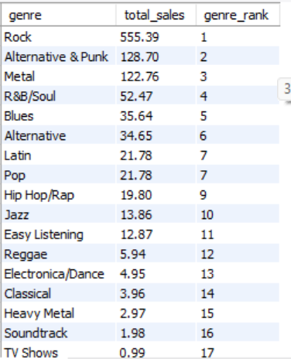
Output

Rock is the best-selling genre in the USA, with total sales of $568.75, followed by Alternative & Punk and Metal.
Genres such as TV Shows, Soundtrack, and Classical have the lowest sales in the USA.

Overall, the ranking clearly shows which genres perform strongest and weakest in the USA. These insights can help identify popular genres and guide future marketing and sales strategies.

- Identify customers who have not made a purchase in the last 3 months
used the latest invoice date in the database as the reference date, and identify customers whose most recent purchase was more than 3 months before that date.
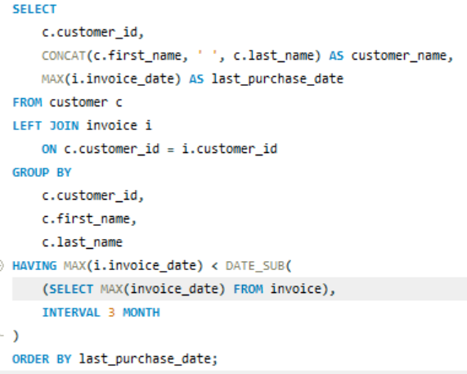

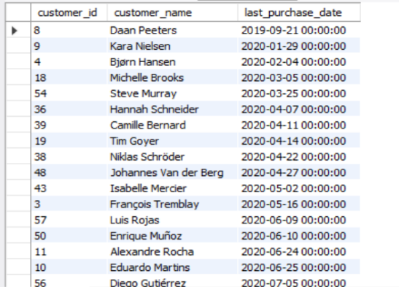
Because the question says last 3 months, but our dataset is historical. We don't want to compare the data against today's date in 2026.
Instead, Take the latest date available in this dataset and look back three months.
- This query identifies customers who have not made a purchase in the last three months. MAX(invoice_date) finds each customer's most recent purchase date, which is compared with the latest invoice date in the dataset using DATE_SUB().
- The HAVING clause keeps only customers whose last purchase was more than three months ago.
The results show customers who have become inactive based on their last purchase date.
These customers can be targeted with personalized offers, loyalty benefits, or promotional campaigns to encourage repeat purchases and improve customer retention.
The results identify inactive customers who may be targeted with personalized offers and promotional campaigns. This can help improve customer re-engagement and retention.

Subjective Questions

Q1. Recommend the three albums from the new record label that should be prioritised for advertising and promotion in the USA based on genre sales analysis.
This analysis builds on the findings from Objective Q9 and Q11, where genre sales performance in the USA was analyzed and genres were ranked based on their sales.
The highest-performing genres identified in those questions are used as the basis for selecting albums from the new record label.
We then compare the sales performance of albums within these high-performing genres to recommend the three albums with the strongest promotional potential.
Use Objective Q11 for the genre-level analysis.
From Q11, we can say:
- Rock — 555.39
- Alternative & Punk — 128.70
- Metal — 122.76
So Q11 tells us which genres should be targeted.
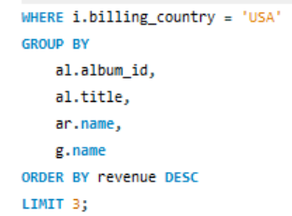
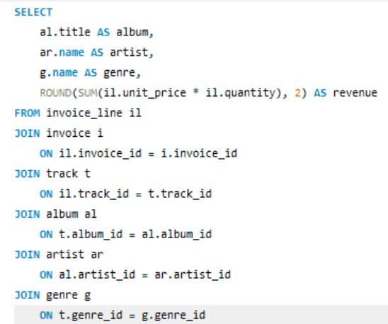

Output
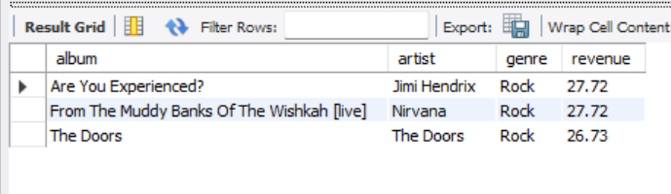

- This subjective question is directly related to Objective Q11 – Rank genres based on their sales performance in the USA.
- Q11 identified Rock as the highest-selling genre in the USA, followed by Alternative & Punk and Metal. Therefore, the findings from Q11 are used as the basis for selecting albums for promotion.
- The album-level sales analysis then helps identify which albums within the high-performing genre should be prioritized for advertising.
Q11 finding used: Rock generated the highest USA sales (555.39), making it the primary genre considered for album promotion.
Insights
Referencing the actual findings from Q9/Q11.
For example:
As identified in Q11, Rock ranked among the strongest-performing genres in the USA. Based on this finding, albums belonging to the Rock genre from the new record label were examined. The album-level analysis shows that From the Muddy Banks of the Wishkah, Are You Experienced?, and The Best Of Van Halen, Vol. 1 generated the highest sales among the selected albums.
Recommendation
Based on the genre-level findings from Q9 and Q11 and the album-level sales analysis, these three albums should be prioritized for advertising in the USA. Focusing promotional resources on albums belonging to already strong-performing genres reduces the risk of promoting products with limited demonstrated demand.
Q2. Determine the top-selling genres in countries other than the USA and identify any commonalities or differences.
Approach
Objective Q11 – Rank genres based on their sales performance in the USA. The findings from Q11 are used as the USA benchmark for this analysis. The current analysis compares genre sales in other countries with the USA results to identify commonalities and differences in customer genre preferences.
- First, I calculated the total sales revenue for each genre in each country using UnitPrice × Quantity.
- The USA was excluded from the analysis, and the genres were ranked separately for each country using the RANK() window function.
- Finally, only the top 3 genres from each country were selected to make the comparison easier and identify commonalities and differences in genre preferences.
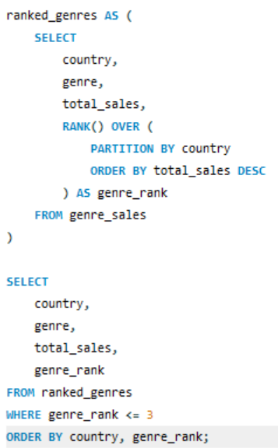
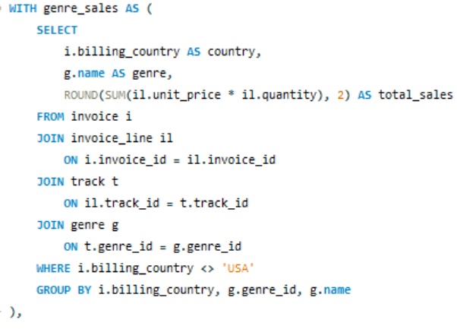
The question specifically asks for countries other than the USA, so the USA is removed from the analysis.
PARTITION BY country means: Start the ranking again for every country, So every country gets its own Rank
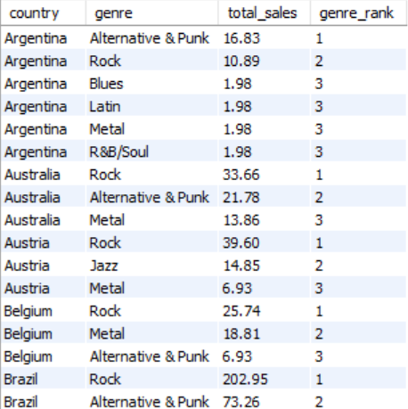
genre_ rank <= 3:This removes all genres ranked below third place. Therefore, instead of having a huge output containing every genre, I have only: Top 3 genres × each country ,This makes the results much easier to analyze.
Output

Insights
After looking at top-3 output
Commonalities
Rock appears among the top-selling genres across multiple countries, indicating that it has broad international popularity.
Other genres that repeatedly appear in the top 3 across different countries also represent common customer preferences.
Differences
The second- and third-ranked genres vary across countries, showing that customers in different markets have different music preferences.
Some countries show stronger demand for genres such as Latin, Metal, or Alternative & Punk, indicating country-specific preferences.
Recommendation
Based on the results, the store should maintain popular genres such as Rock across multiple countries while also adapting its promotions to country-specific preferences. Marketing campaigns and recommendations can be customized by country to promote genres that perform particularly well in each market.

Q3. Customer Purchasing Behavior Analysis: How do the purchasing habits (frequency, basket size, spending amount) of long-term customers differ from those of new customers? What insights can these patterns provide about customer loyalty and retention strategies?
Approach
To compare purchasing behavior, customers are divided into long-term and new customers based on when they made their first purchase.
- Long-term customers: First purchase was more than 12 months before the latest invoice date in the dataset.
- New customers: First purchase was within the last 12 months of the dataset.
Q7 already analyzed purchase frequency and average order value, so it provides the foundation for this subjective analysis. We can extend Q7 by comparing these purchasing measures between long-term customers and new customers.
Q5 provides information about customer spending/revenue, which is useful when comparing the spending behavior of long-term and new customers.
For each group, we compare:
- Purchase Frequency → Average number of invoices per customer
- Basket Size → Average number of tracks purchased per invoice
- Spending Amount → Average total revenue spent per customer
Note: The 12-month classification is an analytical assumption because the question does not specify the exact definition of "long-term" and "new" customers.
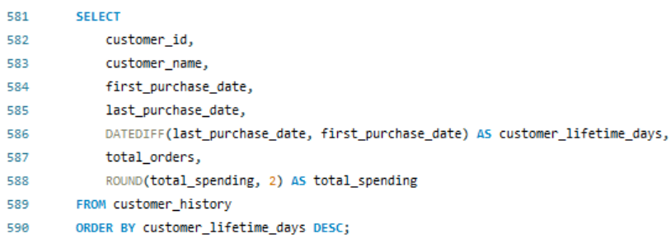
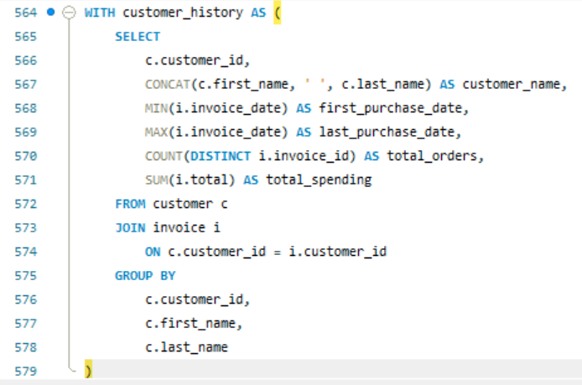
Step 1 : Build customer purchase history
Output
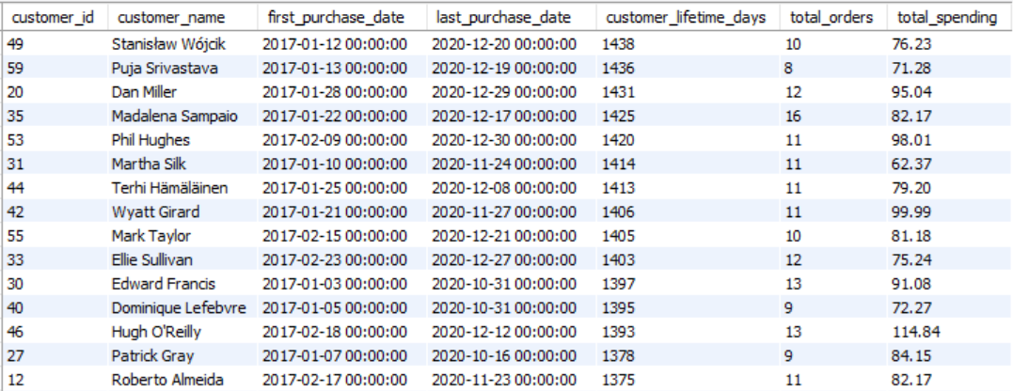

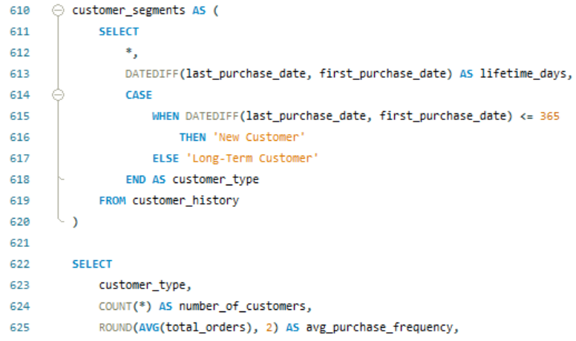
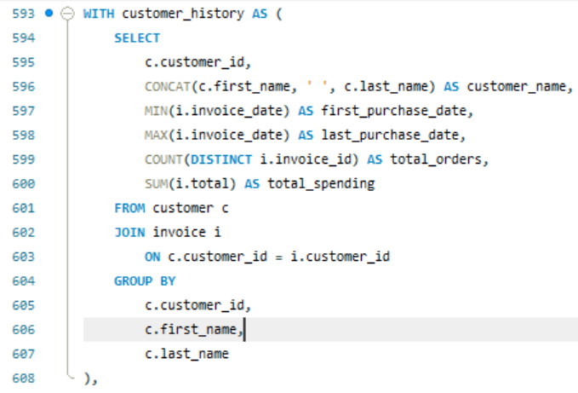
Step 2 : long-term customers
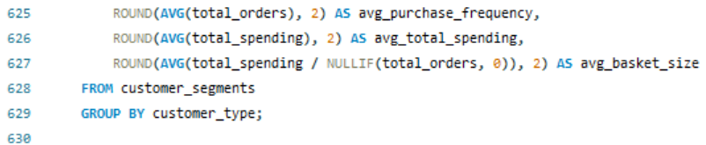
Output
Insights
The purchasing patterns of long-term and new customers can provide important insights into customer loyalty and retention. Customers who make purchases more frequently and consistently over a longer period can be considered more engaged and potentially more loyal
Long-term customers who purchase frequently and spend more are likely to be more loyal and valuable. They should be targeted with loyalty programs, personalized recommendations, exclusive offers, and early access. Customers with larger basket sizes can also be encouraged through bundles and cross-selling.
For new customers, the main goal should be to encourage repeat purchases through targeted promotions, personalized recommendations, and second-purchase incentives. Overall, the company should use different retention strategies to retain valuable long-term customers and convert new customers into loyal buyers.

Recommendation
Pattern | What it may indicate | Strategy
High frequency + high spending | Strong loyalty/high-value customer | Loyalty rewards, exclusive offers
High frequency + small basket | Frequent but low-value purchases | Bundles, cross-selling
Low frequency + high basket | Occasional high-value customer | Personalized recommendations
New customer + one purchase | Risk of not returning | Second-purchase incentive
Long-term + declining frequency | Possible disengagement | Re-engagement campaign

Q4. Product Affinity Analysis: Which music genres, artists, or albums are frequently purchased together by customers? How can this information guide product recommendations and cross-selling initiatives?
For this question, “purchased together” means items that appear in the same invoice. This allows us to identify combinations that customers commonly buy during the same transaction.
I identified pairs of genres, artists, and albums that occur together in the same customer invoice. The number of invoices containing each pair is then counted and ranked to identify the most frequently purchased combinations.
This can help the business understand which products have a natural connection and can therefore be recommended together.

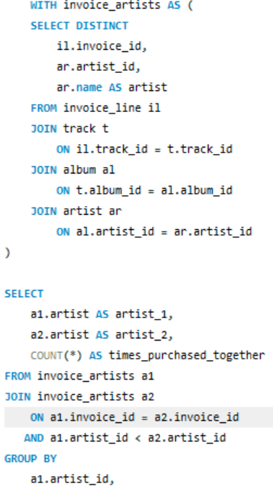
Part 1: Genres frequently purchased together Part 2:Artists frequently purchased together

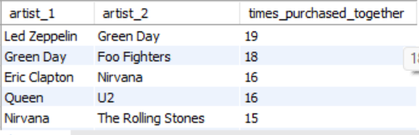
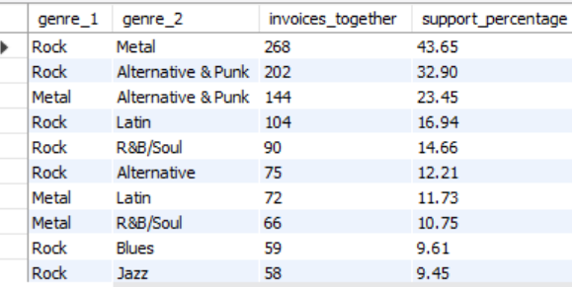
Output

Part 3 Albums frequently purchased together
performed the same analysis for albums:
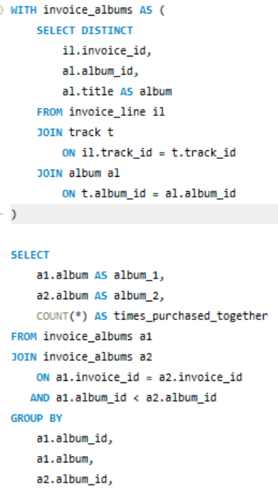
Output
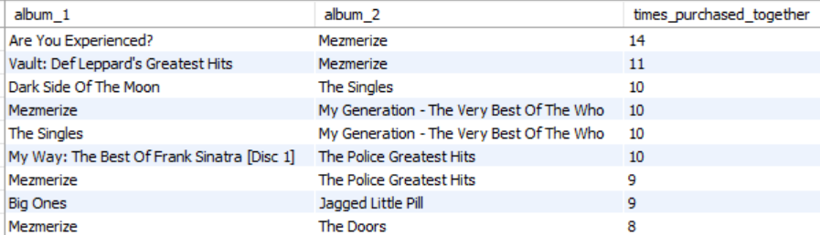

Insights
- The product affinity analysis shows strong relationships between several genres, artists, and albums. The strongest genre combination is Rock and Metal, which appeared together in 268 invoices and had a support of 43.65%.
- Other notable genre associations include Rock with Alternative & Punk, Latin, and R&B/Soul.
- At the artist level, Led Zeppelin and Green Day were the most frequently purchased pair, appearing together in 19 invoices, followed by Green Day and Foo Fighters with 18 invoices.
- At the album level, Are You Experienced? and Mezmerize formed the strongest pair, appearing together in 14 invoices

Recommendation
These patterns can be used to improve product recommendations and cross-selling. Customers purchasing Rock products can be recommended Metal products, while customers purchasing specific artists or albums can be shown their frequently associated products. Strong album combinations can also be promoted as bundles with discounts.
Using these purchasing relationships allows the company to provide personalized recommendations based on actual customer behavior, potentially increasing cross-selling opportunities and average basket size.

Q5. Regional Market Analysis: Do customer purchasing behaviors and churn rates vary across different geographic regions or store locations? How might these correlate with local demographic or economic factors?
- Regional Market Analysis helps identify differences in customer purchasing behavior and customer retention across geographic regions.
- By comparing customers, invoices, revenue, and inactive customers by country, the company can identify strong and weak markets and develop region-specific strategies.
- In the Chinook database, billing country can be used as the geographic region. Store-location analysis is not applicable because the database does not contain physical store information.

Objective Q3: What is the customer demographic breakdown (age, gender, location) of Chinook's customer base?
→ Provides the location and demographic information needed for regional comparison.
Objective Q4: Calculate the total revenue and number of invoices for each country, state, and city.
→ Provides the regional purchasing behavior through revenue and invoice activity.
Objective Q8: What is the customer churn rate?
→ Provides the customer churn analysis, which can be extended to compare retention across regionsAll three objectives

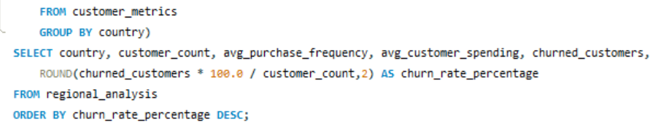
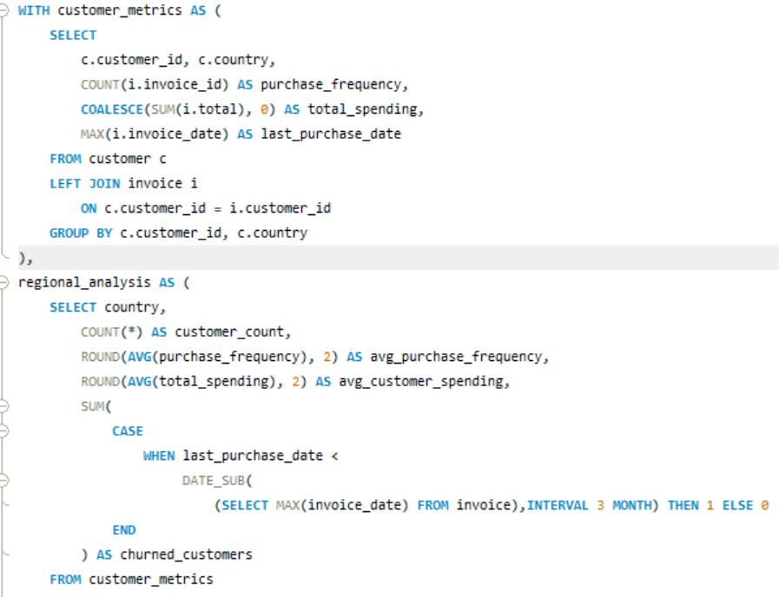
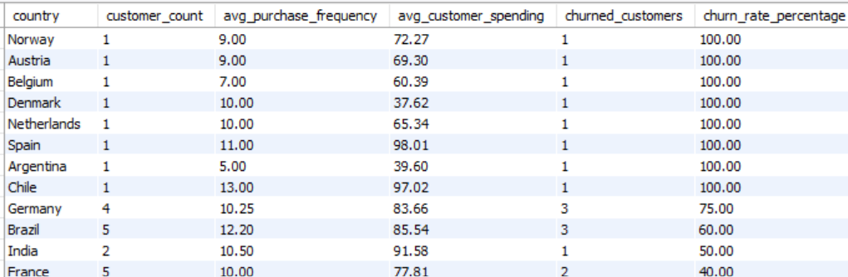
Output

Insights
The regional analysis indicates that customer purchasing behavior and churn rates vary across geographic markets.
Germany and Brazil show particularly high churn rates of 75% and 60%, respectively, despite having relatively high average customer spending and purchase frequency.
This suggests that high-value customers are not necessarily highly retained. The USA has the largest customer base in the dataset and a comparatively lower churn rate of approximately 23.08%, making customer retention in this market strategically important.
Recommendation
Based on these patterns, the company should prioritize retention campaigns in high-value markets with high churn, using loyalty programs, personalized recommendations, re-engagement campaigns, and targeted offers.
Regional customer segmentation should be used so that marketing strategies can be adapted to local purchasing behavior.
However, countries with very small customer populations should be interpreted cautiously because their churn percentages can be statistically misleading.
Finally, demographic and economic factors cannot be directly correlated with the results using the current Chinook dataset because such variables are not available. External demographic and economic data would be required to investigate these relationships.

Q6. Customer Risk Profiling: Based on customer profiles (age, gender, location, purchase history), which customer segments are more likely to churn or pose a higher risk of reduced spending? What factors contribute to this risk?
The standard Chinook database does not contain age or gender fields in the Customer table. Therefore, I did not invent age/gender information. For this analysis, I have used the available customer profile information country/location along with purchase history, recency, purchase frequency, and total spending.
Objective Q3 – Customer demographic breakdown (age, gender, location)
→ Provides the age, gender, and location part of the customer profile.
Objective Q5 – Top 5 customers by total revenue in each country
→ Provides information about customer spending/revenue.
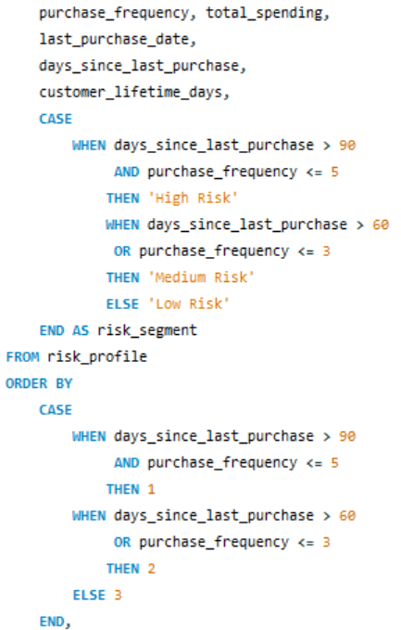
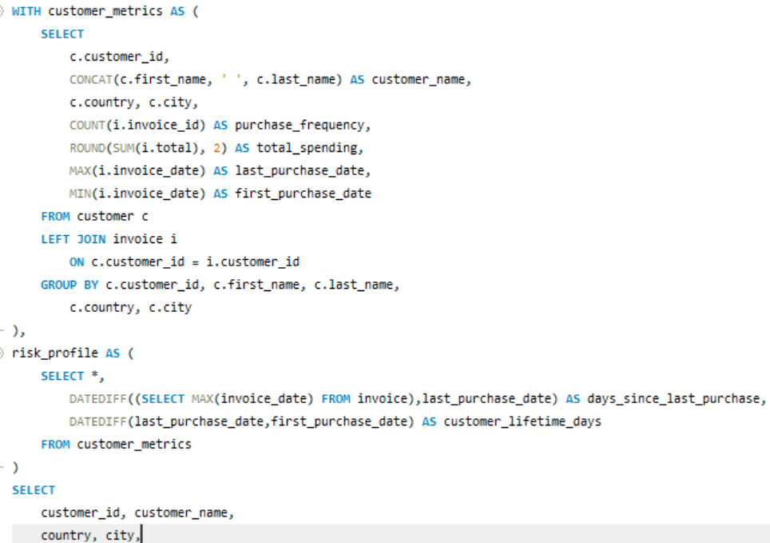
Objective Q8 – Customer churn rate
→ Provides the churn/retention part of the analysis.
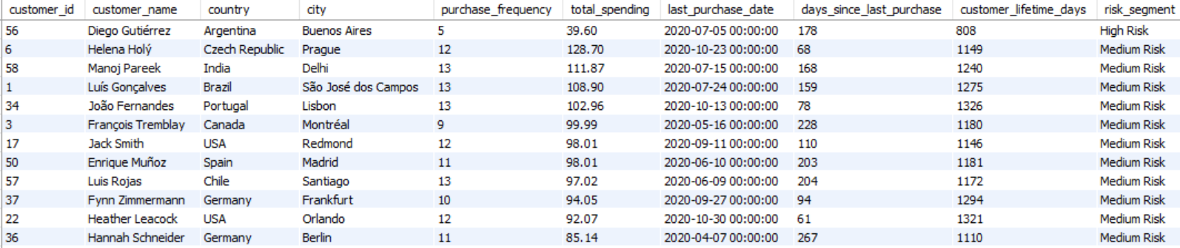

High-risk customers have substantially lower average spending than low- and medium-risk customers, indicating that reduced spending is associated with higher customer risk.
Insights
Purchase recency and purchase frequency are key indicators of potential churn. Diego Gutiérrez is a clear high-risk example, with only 5 purchases and 178 days since his last purchase.
Some medium-risk customers have high historical value but have become inactive. Manoj Pareek spent $111.87 across 13 purchases but has been inactive for 168 days, while François Tremblay spent $99.99 across 9 purchases and has been inactive for 228 days. These customers are particularly important because losing them could reduce future revenue.
Low-risk customers generally show more recent purchasing activity. Franktísek Wichter... made 18 purchases worth $144.54 and purchased within the last 48 days, while Phill Hughes purchased on the latest recorded date.
The risk categories represent customers classified as High, Medium, or Low Risk under the defined criteria, rather than scientifically predicted churn probabilities.
Recommendations
Prioritize high-value inactive customers such as Manoj Pareek and François Tremblay for targeted re-engagement because they have demonstrated strong historical spending but have not purchased recently.
Use stronger re-engagement campaigns for high-risk customers, including personalized offers and recommendations based on their previous purchases.
Use loyalty programs and personalized recommendations for low-risk customers to maintain their engagement and encourage repeat purchases.

Q7. Customer Lifetime Value Modeling: How can you leverage customer data (tenure, purchase history, engagement) to predict the lifetime value of different customer segments? This could inform targeted marketing and loyalty program strategies. Can you observe any common characteristics or purchase patterns among customers who have stopped purchasing?
Approach
We will evaluate customer value using total spending, purchase frequency, and recency. Customers with higher spending and more frequent purchases can be considered higher-value customers, while customers who have not purchased recently can be considered potentially at risk.
Note: The Chinook database does not contain an explicit age, gender, engagement, or CLV field, so we should not claim to predict actual future CLV. We are analyzing historical customer value.
From Q5 I found Customer spending/value,
Q7 :Purchase frequency, basket size and engagement
Q8 :Churn and retention
These objectives already provide most of the information needed for the lifetime-value analysis. However, they do not combine these measures at the customer level to estimate CLV or identify common characteristics of customers who have stopped purchasing.
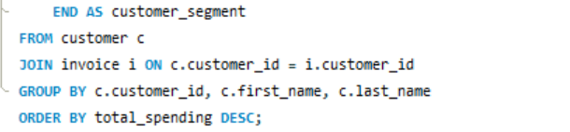
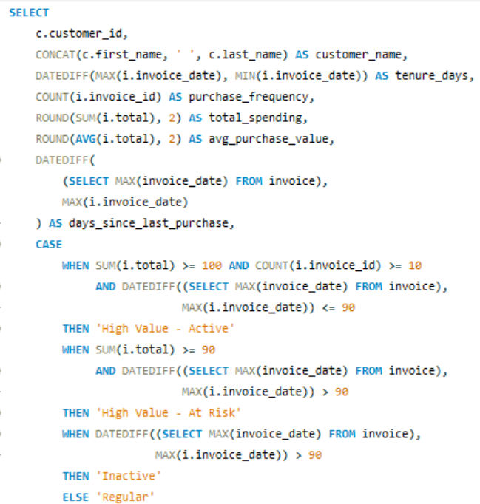

Output
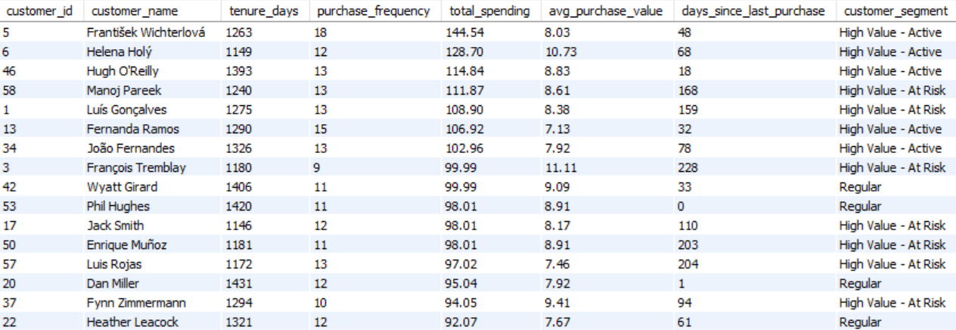

Insights
- Regular customers contribute the highest total spending, making them an important revenue-generating segment.
- Inactive customers have the second-highest total spending, which indicates that the business may be losing customers who previously generated significant revenue.
- High Value – At Risk customers have lower overall segment spending but are important because they have already shown strong customer value and may be at risk of becoming inactive.
Recommendations
Focus on retaining Regular customers through loyalty rewards, personalized recommendations, and cross-selling.
Prioritize Inactive and High Value – At Risk customers with targeted re-engagement offers to encourage repeat purchases.
Monitor purchase frequency and recency regularly so that valuable customers can be identified and contacted before they become inactive.

Q8. If data on promotional campaigns (discounts, events, email marketing) is available, how could you measure their impact on customer acquisition, retention, and overall sales?
Approach
Compare customers who received a promotion with those who did not, and measure differences in new customer acquisition, repeat purchases/retention, and total sales before and after the campaign.
Chinook dataset does not contain promotional campaign data such as discounts, email campaigns, campaign IDs, or event participation. Therefore, this question cannot be directly answered using the current tables.
Analysis
If promotional campaign data such as discounts, events, and email marketing were available, their effectiveness could be measured by comparing customer and sales performance before, during, and after each campaign.
1. Customer Acquisition
The impact on acquisition can be measured by comparing the number of new customers acquired during a campaign with the normal acquisition level.
$$Acquisition Uplift \left(\%\right) \frac{Campaign Acquisition Rate-Normal Acquisition Rate​}{Normal Acquisition Rate}×100$$
A positive uplift would indicate that the campaign may have contributed to attracting new customers.
2. Customer Retention
Retention can be measured by comparing repeat purchase and churn rates between customers who received the promotion and those who did not.
$$Retention Rate \frac{Customers Who Purchased Again​​}{Total Customers}×100$$
A higher retention rate or lower churn rate among promoted customers would suggest that the campaign had a positive effect on customer loyalty.
3. Sales and Customer Spending
The campaign's effect on sales can be evaluated using:
- Total revenue
- Number of invoices
- Purchase frequency
- Average basket size
- Revenue per customer
The change in sales can be measured using:
$$Sales Uplift (\%)=Expected SalesCampaign Sales-Expected Sales​×100$$

This helps determine whether the campaign generated sales above the expected baseline.

4. Campaign ROI
Revenue alone is not enough to determine whether a campaign was successful. Campaign costs should also be considered.
$$ROI (\%) \frac{Incremental Revenue-Campaign Cost​​}{Campaign Cost}×100$$
A campaign with high sales but very high costs may be less effective than a smaller campaign with a better ROI.
5. Data Analytics Approach
A treatment-and-control approach can provide a more reliable measurement. Customers who received the promotion can be compared with similar customers who did not receive it.
KPI | Promotion Group | Control Group
New customers | — | —
Average spending | — | —
Purchase frequency | — | —
Retention rate | — | —
Churn rate | — | —
Average basket size | — | —

The difference between the two groups can be used to estimate the incremental impact of the campaign rather than simply observing overall sales changes.
Recommendations
The company should prioritize campaigns that demonstrate positive acquisition uplift, higher retention, increased spending, and positive ROI.
Different campaign types such as discounts, email marketing, and events should be analyzed separately to identify which produces the strongest results.
The current Chinook database does not contain promotional campaign information, so actual campaign effectiveness cannot be calculated from the available data.
Additional data such as campaign ID, customer ID, campaign type, campaign date, discount, campaign cost, and customer response would be required.
This approach allows promotional decisions to be based on measurable KPIs and customer behavior rather than simply assuming that an increase in sales was caused by the campaign.

Q9. How would you approach this problem, if the objective and subjective questions weren't given?
1. Understand the Business Problem
First, I would understand the purpose of the database and identify the key business areas, such as:
- Customer purchasing behavior
- Sales and revenue
- Popular genres, artists, and tracks
- Customer retention and churn
- Geographic performance
- Product relationships
Explore and clean the data
Check for missing values, duplicates, inconsistent records, and unusual data before analysis.
Understand and Explore the Data
I would examine the database structure and identify the tables, columns, primary keys, and relationships between tables.
Define key KPIs
Identify metrics such as total revenue, number of customers, invoices, average order value, purchase frequency, customer spending, and customer retention.
Perform Exploratory Data Analysis
I would use SQL to investigate patterns and trends in the data.
For example, I would analyze:
- Which countries generate the most revenue?
- Which genres and artists are most popular?
- Who are the highest-value customers?
- Which products are purchased together?
- How does purchasing behavior differ across regions?
- Which customers appear to be at risk of churn?
Segment Customers
I would divide customers into meaningful groups based on their behavior, such as:
- New vs long-term customers
- High-value vs low-value customers
- Active vs inactive customers
- Low-risk vs high-risk customers
This would help identify different customer needs and potential retention opportunities.
Identify Patterns and Business Opportunities
After analyzing the data, I would look for relationships that could support business decisions.
For example: If Rock and Metal are frequently purchased together, Metal could be recommended to customers purchasing Rock.
Similarly, customers with high historical spending but long periods of inactivity could be targeted with retention campaigns.
Visualize the Findings
I would create dashboards or Excel visualizations to communicate important findings using:
- Bar charts
- Line charts
- Pie charts
- Scatter plots
- Tables/KPI cards
The visualizations would focus on the most important business metrics rather than displaying every available column.
Give actionable recommendations
Convert the findings into business actions related to customer retention, targeted marketing, popular products, cross-selling, and regional performance.
Conclusion
Without predefined questions, I would follow a complete data analytics lifecycle: understand the business and data, explore and clean the data, define KPIs, perform SQL-based analysis, segment customers, identify patterns, visualize key findings, and finally provide actionable business recommendations.

Q10. How can you alter the "Albums" table to add a new column named "ReleaseYear" of type INTEGER to store the release year of each album?
I have added a new column called ReleaseYear to the album table, with the data type INTEGER.
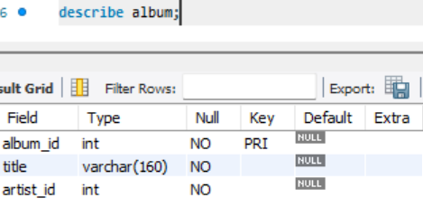
Before adding the new column:
The album table originally contained three columns: album_id, title, and artist_id.

After adding the new column:
The ReleaseYear column was successfully added to the album table with the data type INTEGER, making it the fourth column in the table.
Explanation
- ALTER TABLE album : modifies the existing album table.
- ADD COLUMN ReleaseYear : creates a new column named ReleaseYear.
- INTEGER : specifies that the column will store whole-number values such as 1998, 2005, or 2020.
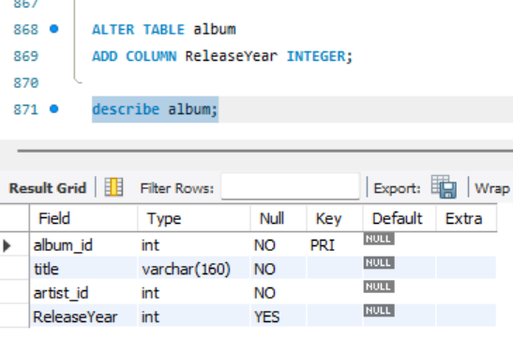
After executing the query, the table will conceptually look like:

11. Chinook is interested in understanding the purchasing behavior of customers based on their geographical location. They want to know the average total amount spent by customers from each country, along with the number of customers and the average number of tracks purchased per customer. Write a SQL query to provide this information.
Approach
- Identify relevant tables: Customer, Invoice, and Invoice_Line.
- Calculate customer-level metrics: total spending and total tracks purchased.
- Group customers by country.
- Calculate: number of customers, average total spending, and average tracks purchased per customer.
- Compare countries to identify high-value and high-volume markets.
- Used the findings to support customer targeting and retention strategies.
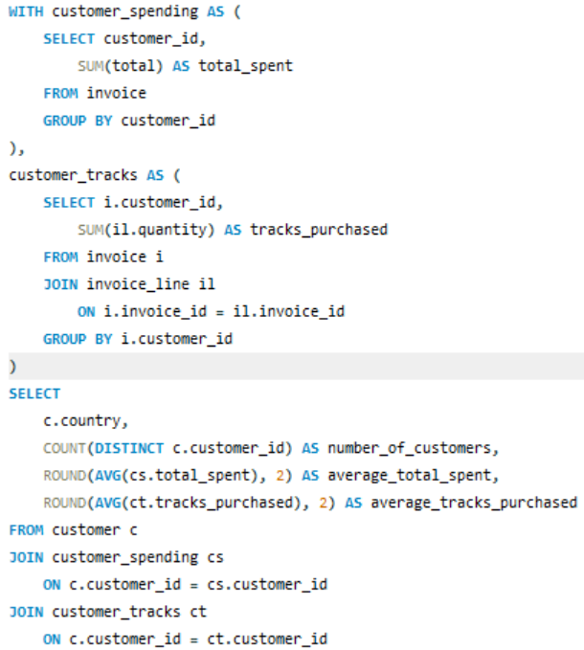
This approach directly covers all three metrics asked in the question and makes the country-level comparison clear.

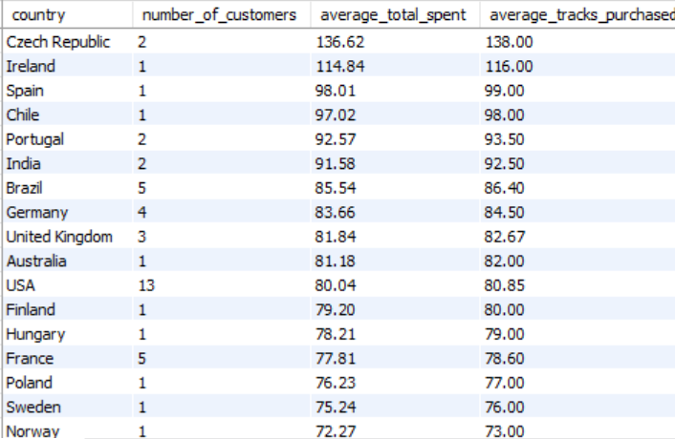
Output

Insights
- Czech Republic: Highest average spending ($136.62) and average tracks purchased (138), but based on only 2 customers.
- Ireland: High average spending ($114.84), but represents only 1 customer.
- USA: Largest customer base with 13 customers and average spending of $80.04, making it an important market.
- Brazil & Germany: Also show relatively strong customer spending and track purchases.
- Overall: Smaller countries show higher averages, while the USA has stronger customer volume.
Recommendations
- Prioritize large markets like the USA for customer retention and revenue growth because they have a larger customer base.
- Investigate smaller high-value markets such as the Czech Republic and Ireland for potential expansion.
- Use premium recommendations, cross-selling, and personalized promotions in countries with high spending and purchasing activity.
- Consider both average customer value and customer volume when deciding where to focus marketing efforts.

